Department of Computer engineering and application

**IOT BASED SMART GATE**

**REPORT**



**Institute of Engineering & Technology**

**Submitted to:- Submitted by:- Mr.Amir Khan Sparsh Agrawal(Sec A)**

**(Assistant professor) Manav Singh(Sec E)**

Department of Computer engineering and application

**INDEX**

➢ INTRODUCTION

➢ OBJECTIVE OF THE PROJECT

➢ FUNCTIONALITY PROVIDED

➢ METHODOLOGY

➢ SOFTWARE TO BE USED

➢ HARDWARE TO BE USED

➢ FUTURE SCOPE

➢ CODE

➢ CONCLUSION

Department of Computer engineering and application

**INTRODUCTION:-**

The aim is to make a gate to protect people from corona at gates because where ever we go every one checks our temperature first. At that time some people touches each other by mistakenly. By this gate they can maintain distance from each other. In this gate we have mlx 90614 sensor for checking temperature, ultrasonic sensor for distance mapping, servo motor for open the gate automatically and we have a device in which we have a data for that person who passes the gate

Department of Computer engineering and application

**EXISTING SYSTEM:-**

At that time we have a machinelike this but in this gate we have a servo motor which open gate automatically with in certain temperature.

**OBJECTIVE OF THE PROJECT:-**

The main objective is to protect our family members and other people from corona virus.

Department of Computer engineering and application

**FUNCTIONALITY PROVIDED:-**

**•** It can check the whole body.

• It shows the details of that person who passes from this gate like body temperature, pulse, thermal vision of the body.

• It shows the detail of that person**.**

**METHODOLOGY:-**

When any person passes through this gate it will identify the person body temperature if temperature is within a certain range then servo motor open the gate .

Department of Computer engineering and application

**LAYOUT:-**

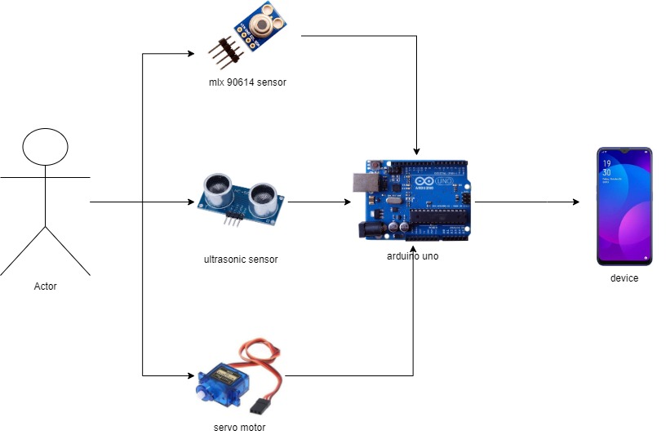

Department of Computer engineering and application

**SOFTWARE REQUIRMENTS:-**

• Windows 7 or Higher

• Any operating systems

• Any android mobile phone

**HARDWARE REQUIRMENTS:-**

• Servo motor

• MLX 90614 sensor

• Arduino uno

• Ultra sonic sensor Etc.

**Future Scope:**

• We can use it in many places like hotels, restaurants, malls, banks. Etc.

• It can save many people from corona.

• It reduces labour

Department of Computer engineering and application

**CODE:**

#include <Wire.h>

#include <Adafruit_MLX90614.h>

#define trigPin 7

#define echoPin 6

Adafruit_MLX90614 mlx = Adafruit_MLX90614();

void setup() {

Serial.begin(9600);

pinMode(trigPin, OUTPUT);

pinMode(echoPin, INPUT);

mlx.begin();

}

void loop() {

long duration, distance;

digitalWrite(trigPin, LOW);

delayMicroseconds(2);

digitalWrite(trigPin, HIGH);

delayMicroseconds(10);

digitalWrite(trigPin, LOW);

Department of Computer engineering and application

duration = pulseIn(echoPin, HIGH);

distance = duration*0.034/2;

Serial.print("distnace:");

Serial.println(distance);

Serial.print("temp :");

Serial.print(mlx.readObjectTempC());

Serial.println("*C");

delay(2000);

**}**

Department of Computer engineering and application

**CONCULSION:-**

At the end of this project, we will get a fully functional smart gate.

**WEBSITE REFERENCE:-**

[www.google.com](http://www.google.com)